Software Requirements Specification
For
Mess Management Service
(Manage all mess works of a mess manager)
Version 1.0 approved
Prepared by:
1.Shreshthajit Das(2017831013)
2.Fahim Tajwar Saikat(2017831020)
3.Abdullah-Al-Foysal(2017831032)

Date :10/07/2019

Submitted to:
Sayma Sultana Chowdhury
Assistant Professor,IICT,SUST

Table Of Contents
1.Introduction 1
1.1 Purpose 3
1.2 Document Convention 3
1.3 Reading Suggestion 3
1.4 Project Scope 4
1.5 References 4
2.Overall Description 4
5 2.1 Product Perspective 4
5 2.2 Product Features 4
2.3 User Classes & Characteristics 6
2.4 Operating Environment 7
2.5 Hardware Requirement 7
2.6 Design and Implementation Constraints 7
3. External Interface Requirements 10 3.1 User Interface 8
3.2 Hardware Interface 8
3.3 Software Interface 10
3.4 Communication Interface 12
4.System Features 17
4.1 System features elicitation 15
4.2 Use-case Diagram 15
4.2.1 System Log-In 15
4.2.3 System Notification 16
4.2.4 Other Features 16
4.3 Add Deposit 16
4.4 My Calculation 17
4.5 Mess Cash board 17
5.Nonfunctional Requirements 18
5.1 Product Requirements 18
5.1.1 Usability Requirements
5.3. External Requirements 18
5.3.1 Regulatory Requirements 18
5.3.2 Ethical Requirements 18
5.3.3 Legislative Requirements 18
5.1.2 Efficiency Requirements 19
5.1.4 Security 19
5.2. Organizational Requirements 19
5.2.1 Environmental Requirements 19
5.2.2 Operational Requirements 20
5.2.3 Development Requirements 20
6 Other Requirement 21
6.B.1 Functional Decomposition Model Of MMS 21
6.B.2 UML class diagram of MMS 22
6.B.3 Use case Model for MMS 23

Revision History
Name | Date | Reason For Changes | Version
First Version | 11.03.19 | Initialize | 1.0
Second Version | 10.07.19 | Update | 1.1

Introduction

Purpose
According to Mess Management ,This System will provide those Services, which users need immediately and co-Operating with all Member of a Mess.
Mess Management System will improve all Activities of a Mess those will be shown on product scope .
Our survey of what people want from us for a mess management system shown below:
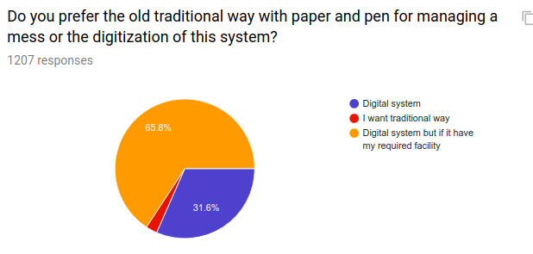
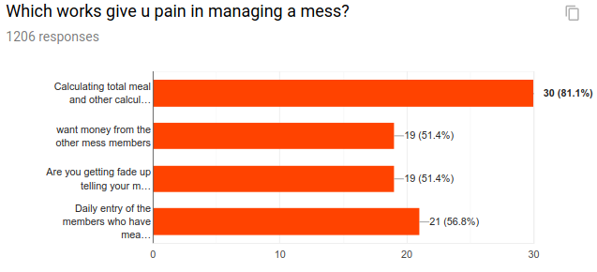

Document Conventions

This document uses the following conventions.

- SRS | - Software Requirements Specification
- IEEE | - Institute of Electrical and Electronics Engineers
- OS | - Operating System
- IDE | - Integrated Development Environment
- OOP | - Object Oriented Programming
- SQL | - Structured Query Language
- DFD | - Data Flow Diagram
- CFD | - Context Flow Diagram
- UML | - Unified Modeling Language

- MMS : Mess Management Service
- Super Member: Mess Manager(Service maintainer)
- Member: Mess Member

Intended Audience and Reading Suggestions

This is a prototype for an online based system that will serve all needed information about MESS Member & Activities of Mess .This report is intended for several audiences, including the customer, as well as the project managers, designers, developers, and testers. Some recommended topic for readers:
●Customer: The customer will use this document to ensure that whatever he requires has been fulfilled by the project teams.
●Project Manager: The project managers of the developer team will use this SRS to fix a milestone and time to deliver the software and to ensure that the teams working on this project are on the right path.

● System Tester: The testers will use this SRS to derive test plans and test cases for each documented requirement. When portions of the software are complete, the testers will run their tests on that software to ensure that the software fulfills the requirements documented in this SRS.
● System Architect: The system architect will enable to understand how the system should be design according to this srs and this will ensure the needs of
the clients or user of the system.
● Developers: The developers will use this report as a basis for developing the system’s functionality. The developers will link the requirements defined in this SRS to the software they create to ensure that they have created software that will fulfill all of the customer’s documented requirements.

● Public/User: Project scope, Product features, System features.

Product Scope

Mess Management Service is a online based software.MMS will enable the mess member to calculate all necessary information & calculation automatically from any where.Any one of the member can access the mess activities and add necessary information such as Bazar cost,Add meal,Task reminder,Deposit money etc.

This srs will enable users to have an overview of the system features and it’s pursposes ,benfits,objectives ,goals.

Purpose:Different types of Reader will get overview of the Mess Management System.

Benefits: This document can make the readers to understand about all features and functions as the client wanted.MMS will save the time and space of calculation for all of the user of the system.

Goals: The main goals is to Save time and works of calcultation to the Mess members.The srs will give an totall overview of the system pupose and benefits to the system users ,client engineer,Architecture,client manager and developers.

References
1.”Meal Manager” on Android Play Store.
2. “Meal Expense”

Overall Description

Product Perspective
Mess Management System is a software where all activity of a mess is done with digitalization system rather than pen and paper.As it is online base it will accessible from any where and maintain mess activities.

Product Functions
- Create Mess Account
- Add member
- Add Daily meal & update
- Add Daily cost & update
- Add extra cost & update
- Task Remainder(schedule)
- Report
- Notification
- Add & Delete member

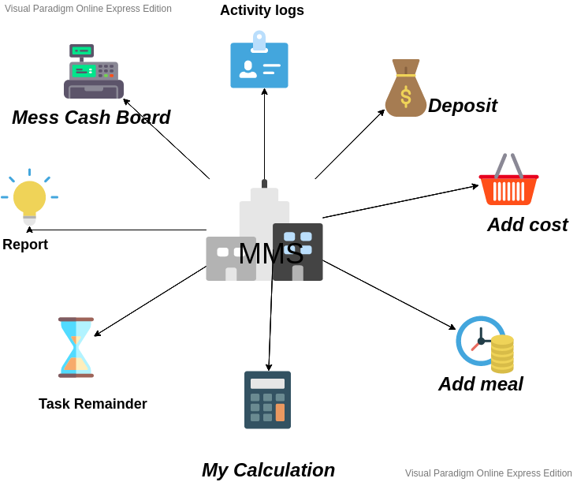

- Create Mess Account:
- Add member:
- Daily Meal:
The members of the mess can book for meal daily before the bazar. They have option for auto meal book or cancellation any meal from this option.Previous meal count can’t update which has the only authentication to Mess Manager.
- Add extra cost:
The members of the mess can add extra cost except meal with the permission of the mess manager. For example if we buy a handwash for the mess it will obviously not go in the section of meal. Any members of the mess can add the cost of purchasing handwash to the extra cost section. Users have a short note section so that they can recall which item they had bought in future.
- Task Scheduler:
Any member can create a task and set a schedule for this task.Every member who are added to this task will notify when task is added and also when task is going to start and finish before the date or weekdays.

- Add Bazar Cost: Any member can add bazar cost which is belongs to Meal.
Irrevant cost will add to Add extra cost.
Only Mess Manager can update any information with will notify to all Members.

- Deposit Money:
This section is only for Mess Manager or super admin.After getting money from any member, super admin will add Deposit Money.

- Mess Cash Board: Current Deposit ,cost,Meal Rate will auto update here.

- My Calculation: Meal Rate, Deposite money,need to pay .

User Classes and Characteristics
Main user of this system are all members of a mess and the user’s of the system are:

1.Mess Manager
2.Member

user | User class characteristics
Mess Manager | - Create Mess Account  - Create Member Account  - Add Member  - Remove member  - Update Meal  - Update Task  - Update Cost  - Update Deposit  - Update Task  - Update Schedule  - Delete Mess Account  - Change Mess Manager
Member | - Add Meal  - Add Cost  - Add Deposit  - Create Schedule  - Create Task

- Users: who are able to use Smart phone or Personal Computer .
- Users Education Level:A Good command in English or Bangla.
- Frequent User: Student community, A group of People with Different Jobs living togather.

Use Case Diagram Of the system:
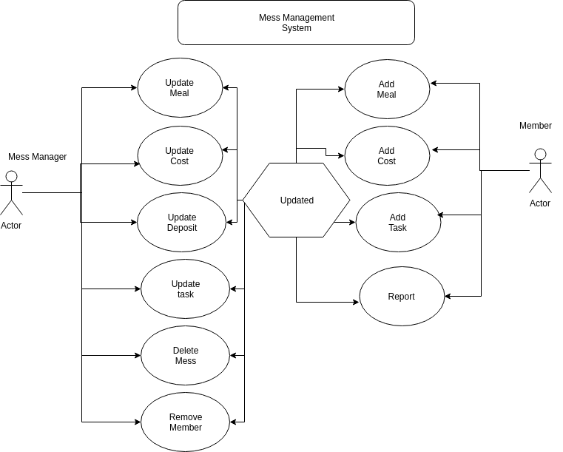

Operating Environment

- Android
- Windows 2000
- Windows XP
- Windows Vista
- Windows 7
- Windows 8
- Windows 10
- Mac OS X
- Linux

Design and Implementation Constraints

Mess Management System will be developed in Java both for android and web-based version.It will be developed using eclicpe Ide platform.Here we also use Html,Css,Java Script etc. for front-end design.

User Documentation
See product scope & product function..

Assumptions and Dependencies
MMS will be used in java and therefor requires Java to be installed on the user’s system. The final system need Java version 8.This applies to windows,linux and android version.
Here we also some assumptions which are given below:

- System won’t Failure or crash
- Hardware won’t fails to load
- Always Connect to internet or web server.

External Interface Requirements

User Interfaces
User should have a friendly user interface and easy to understandable option to use.

3.1.1 MMS Login interface prototype:
There will be common login screen for all users.But the internal interface will be different based on the user type.Login screen will ask Email and a password from the user.
Also Sign up for new user and password forgot for old user.

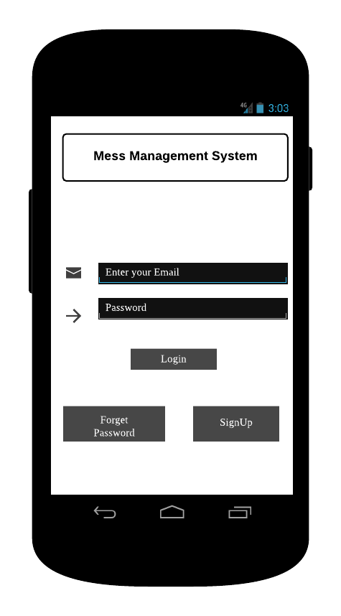

3.1.2 MMS Home Screen:

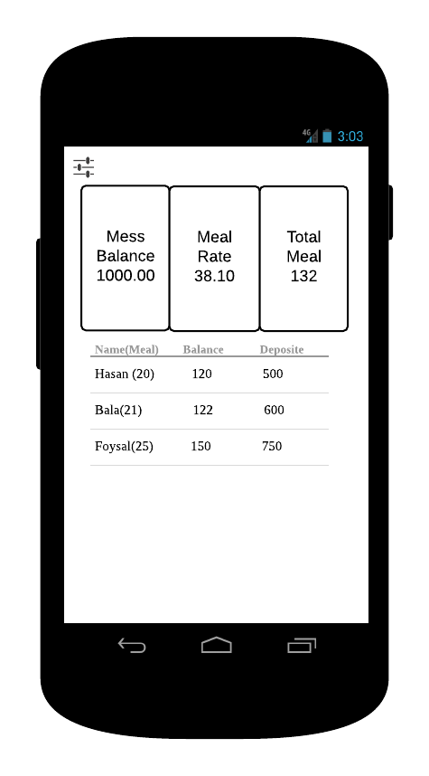

3.1.3 MMS Menu screen prototype:
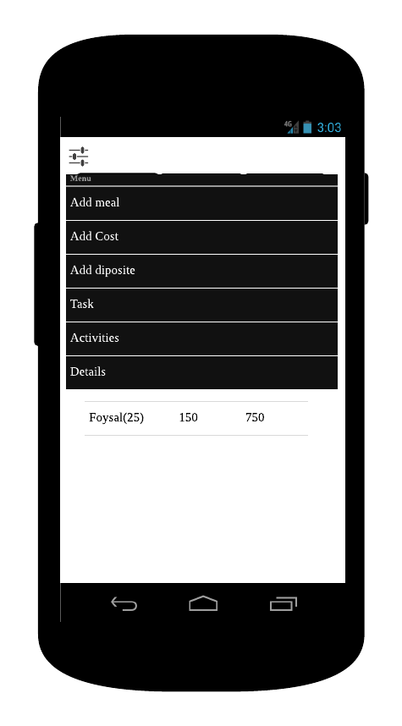

3.1.4 MMS Add Deposit screen prototype:

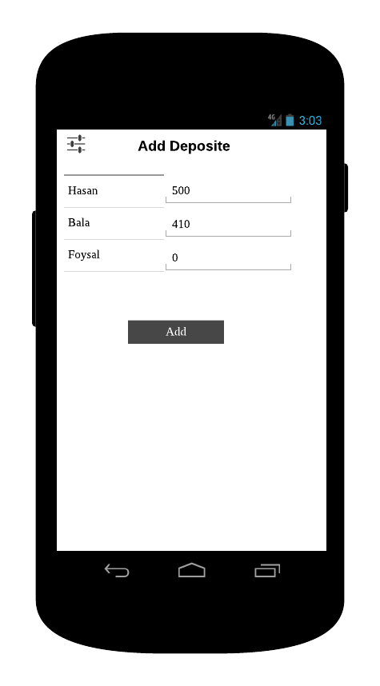

3.1.5 MMS Add Cost screen prototype:
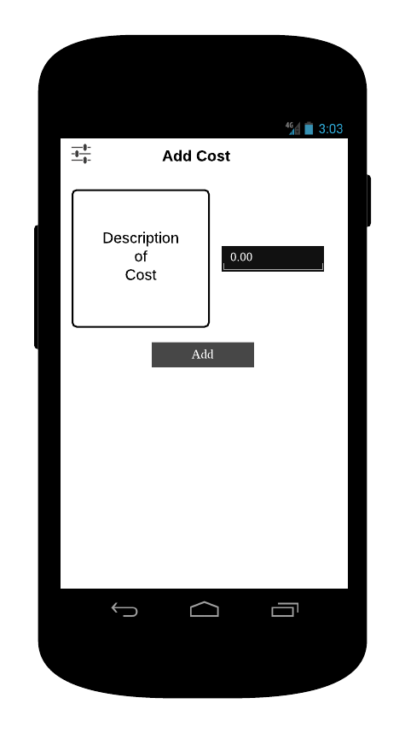

3.1.6 MMS Add meal screen prototype:

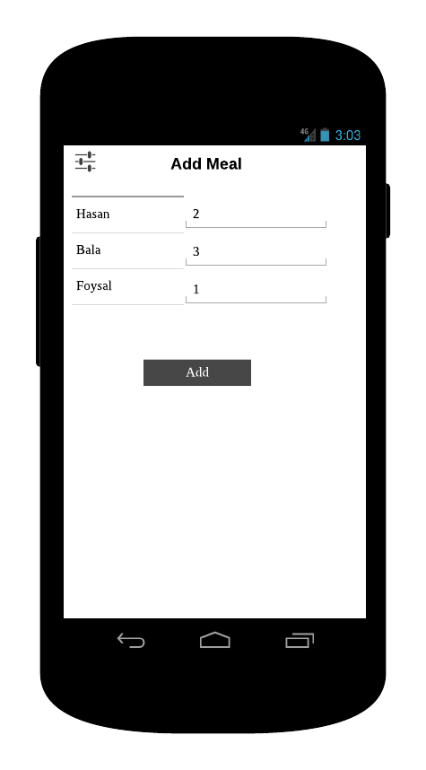

3.1.7 MMS Task screen prototype:

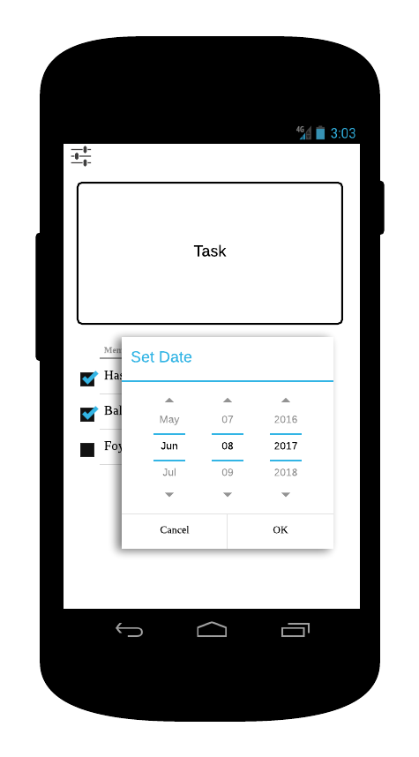

Hardware Interfaces

Operating System: Windows,Linux,Android
CPU:Pentium processor at 90 MHz or higher
Memory: 2GB RAM
Hard Drive:50 MB available in the Hard Disk
Graphics hardware: DirectX 3.0 or higher

Software Interfaces
MMS requires Java to be installed on the system,more specially Java 8 for it’s final release.
MMS also connected with a MySQL for database management.

Communications Interfaces

MMS requires internet connections to operate.The whole system works throw internet.

Connecting to Mess Management service:

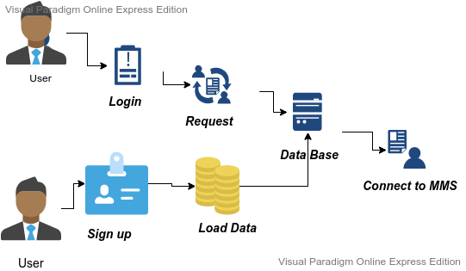

Communication interface

System Features

Mess Cash board
4.1.1 Description and Priority:
Here Mess Cash board updates automatically after user input. It is an overview of total collected money and spend money.
4.1.2 Stimulus/Response Sequences:
Users have to add data of bazar and meal manually and these response will be used to calculate the mess cash board
4.1.3 Functional Requirements

REQ-1: A simple Database
REQ-2: Network connectivity

Add Cost

4.2.1 Description and Priority:
Here are two types of cost. One is equally distributed among the members of the mess, another is distributed by weight(numbers of meal) among the me mbers of the mess.
4.3 Add Deposit

4.4 My Calculation
4.4.1 Meal Rate :
we will divide total cost of Meal by total number of meal. Then will find Meal rate.
4.4.1 My Balance
My Balance = My Deposit – My Meal*Meal Rate – Equally Distributed Cost / Number of mess member
4.5 Mess Cash Board
4.5.1 Mess Balance
Mess Balance=Total Deposit-Total Cost
4.5.2 Total Cost
Total Cost=Total Meal Number* Meal Rate + Equally Distributed Cost
4.5.3 Meal Rate
Meal Rate= Total Meal Cost / Total Meal

Other Nonfunctional Requirements

Performance Requirements

5.1 Safety Requirements

I.Overview:
This term will show the main functionality of this software.
II.Specification:
Here the specified requirements for this software must be specified.Clear,precise,unequivocal,verifiable,maintainable,testable,commensurate with the safety integrity level.
III.Desighn and development:
Equipment ,capacity and operator time interface with response time performance.
Iv.validation:
Here the validation process includes:
->>>Gathering and analysis of the specifications and requirements.
->>>Based on specificGations and requirements, preparation of test strategies,plans and cases, that seems fit for use.
->>>Go for testing the boundary values along with stress and functionalities test.
->>>Test the error message.
->>>Conducts software evaluation, as it ensures that the software meets the all pre-decided requirements and is acceptable for use.

Security Requirements
I.Log in:
This option is a must for user for opening a acount for using this app;
II.Email including:
For every member of the mess an account should be opened.
III.password or pin number:
Apassword or pin number will need to add here for every member to safe secure for his acoount.
IV.Email verification code:Email verification code will need to verify when opening a new account.
v.Mobile number:
The mobile number of every mess member will help him for sending the email verificaton code.

Software Quality Attributes
.
Reliability: Reliability of a software system derives from
- Correctness
- Availability
The behavior over time for the fulfillment of a given specification depends on the reliability of the software system.
Adequacy: Factors for the requirement of Adequacy:
- The input required of the user should be limited to only what is necessary. The software system should expect information only if it is necessary.
- The results produced by the software system: The results that a software system delivers should be output in a clear and wellstructured form and be easy to interpret.
Learnability: Learnability of a software system depends on:
- The design of user interfaces
- The clarity and the simplicity of the user instructions (tutorial or user manual).
Robustness: Robustness reduces the impact of operational mistakes, erroneous input data, and hardware errors.

Business Rules
A business rule typically consists of the following information, in the order specified:
- Definitions:At the beginning of the rule, we have to set parameters that identify business terms by using easy to understand names.
- Conditions:The conditions section of the rule contains the “if” statements.
These statements define the conditions under which actions are completed.
6.Other Requirements
Appendix A: Glossary
Appendix B: Analysis Models
6.B.1 Funtional Decomposition Model of MMS
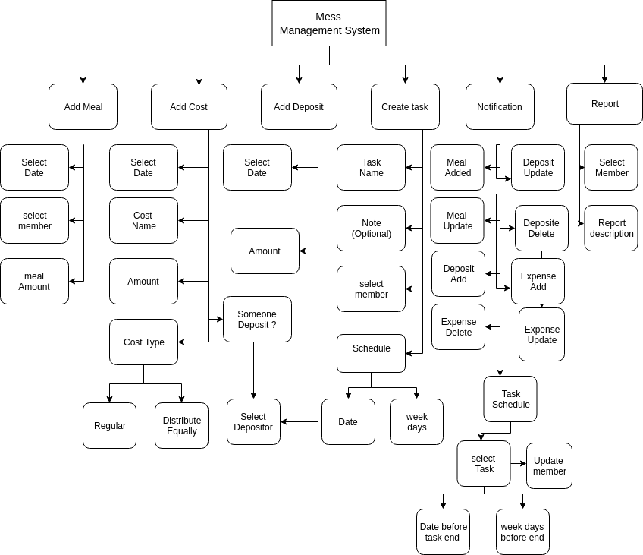
fig:Functional Decomposition
6.B.2 UML class diagram of MMS
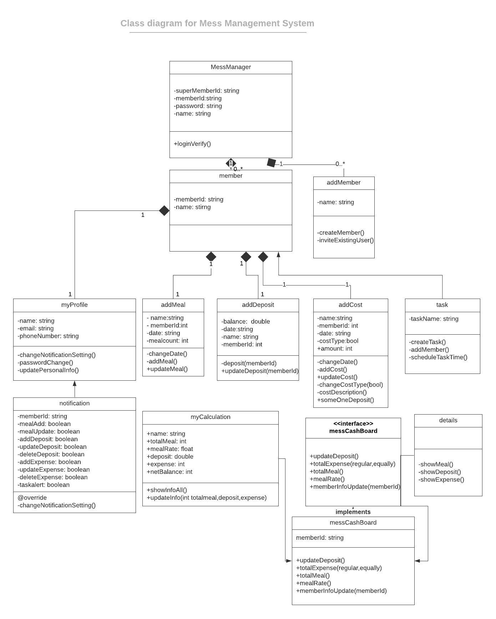
6.B.3 Use case Model for MMS

END

